Kitegirl abilities

Contents

Basic 2

Steroid 3

Offense 4

Defense 5

Mobility 5

Ultimate 6

# Basic

**Ability updates**

**Chain bullets -> Bouncing Bullets**

(Active) next 3 attacks chain dealing 90% of the damage -> (Passive) All basic attacks chain (2) times dealing (33%) of the attack’s damage

**Fleeting Swiftness**

(Active) For the next 3 seconds, damaging an enemy grants you 1 stack of deftness -> Ability is now a steroid

**New abilities**

**Heavy Impact**

(Passive) All basic attacks damage enemies in a (small) cone behind the attack for (33%) of the attack’s damage

**Sticky Bombs**

(Passive) All basic attacks apply a sticky bomb that explodes after (3s) dealing (33%) of the attack’s damage in a (small) area.

**Piercing shot**

(Passive) All basic attacks pierce (1) time(s).

# Steroid

**Fleeting swiftness**

(Active) For the next 3 seconds, damaging an enemy grants you 1 stack of deftness.

Cost: 25 resource.

**Weak point**

(Active) Your basic attacks grant you (5%) crit chance and crit damage. This effect ends when you crit.

Cost: 25 resource.

**Flame on**

(Active) For the next (3) seconds, all your attacks apply burning. (Passive) Your burning damage is increased by (10%)

Cost: 25 resource.

# Offense

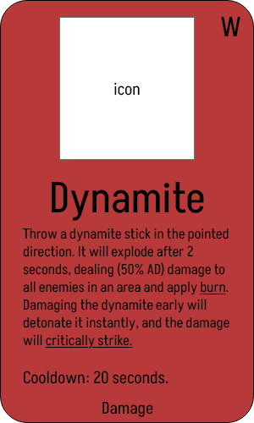

**Ability changes**

**Disintegrate**

Instantly fires a laser in the pointed direction that deals (120% AD) damage and slows enemies by (33%) for 2 seconds. 16 seconds cooldown **->** After a (basic attack cooldown) delay, fire a laser in the pointed direction that deals (100%) AD damage and slows enemies by (20%) for (3) seconds.

Cooldown -> Costs 60 resource.

**Dynamite**

Area: small -> medium

Cooldown -> Costs 60 resource.

**New abilities**

# Defense

**Resourceful**

(Active) Instantly regenerate (50%) resource.

Cooldown: 20 seconds.

# Mobility

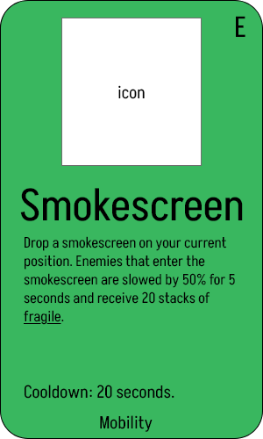

# Ultimate

